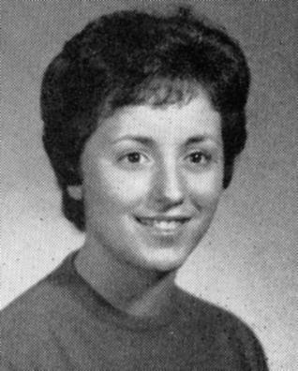
Sara Linda BISHOP Cavanagh
4010 Heathersate, Houston, TX 77084
(281) 550-3392
Taught for 30 years in Texas. Retired. Daughter in Florida. Husband still working. Would love to see everyone.

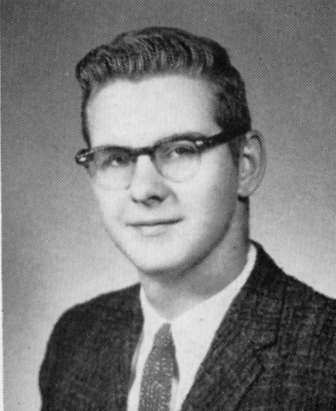
Larry CHRIST
157 Huntleigh Dr, Belleville, IL 62220-3038
(618) 235-3040 larrysue97@charter.net
I married Sue Ellen Junker September 6, 1965 and she is still my best friend today.

We have a son Brian Christ living in Burlington Iowa, with an eight-month-old daughter and a new arrival expected June 2003. Our Daughter Angela is married to Paul Rogers, a Sergeant in the U.S. Air Force. They are stationed in Honolulu Hawaii for the next four years and their 7-year-old daughter and 3-year-old son love it. Sue and I are traveling much of the time to enjoy being with family.

I completed my 35-year banking career in October 1997 and spend my time investing, painting, and volunteer work.

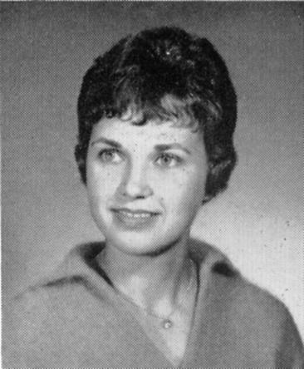
Judy COOK Scheibel
357 West Lake Drive, Edwardsville, IL 62025.
(618) 692-0862 gryschbl@aol.ccom
Spouse: Gary. Judy earned a B.A. and M.S. from the University of Kentucky and SIU-E.

Since 1978, I have been working at the National Imagery and Mapping Agency in 1996 in St. Louis, Chief Staffing Division: Directorate of Civilian Personnel. I will retire in January 2003, and begin pursuing another area of interest although I have not quite decided what it will be. I also plan to do volunteer work but I have not worked out the specifics. I continue to play tennis and enjoy it very much.

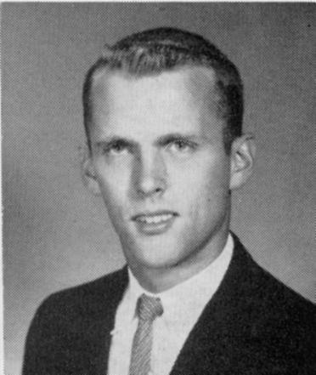
Kenneth Bert EVANS
3660 Buckthorn Ln, Downers Grove, IL 60515-1357
(630) 964-0016 bevans9133@aol.com
Following high school Bert immediately attended SIU and McKendree, graduating with a Bachelor's degree in Business and Economics.

He was married to Fran Allgire and they had two children, Ken and Kurt, before divorcing in 1974. Since then Bert has been happily married to Janet Jestice Evans for the last 28 years and they have a son, Kent Jestice Evans, 19, who is currently a sophomore attending the College of Commerce and Business Administration at the University of Illinois in Urbana-Champaign majoring in Finance. They also have a West Highland White Terrier named Alabaster (Allie) Evans residing with them in Downers Grove, Illinois.

Bert is retired after having a successful 23 year career as a Finance and Administrative Manager with Xerox Corporation in the Chicagoland area. During Kent's 12 year ice hockey career, Bert served as Manager of several of Kent's ice hockey teams. Since then Bert enjoys golfing, photography, gardening, reading, and travelling.

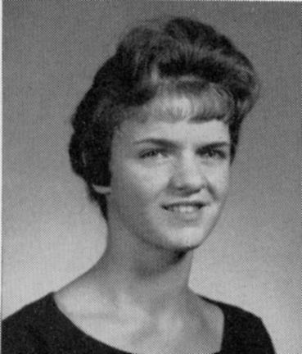 | 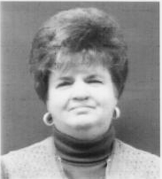
Carolyn GAIN Faries
113 Las Olas, Belleville, IL 62221-2679
(618) 233-3244 carolyn.faries@gsa.gov
Upon graduation, I went to work at Prudential Insurance Company until 1969 when I left to have my son Tim. In 1971, I went to work for the government-General Services Administration-where I still work today.

I have been married to my husband Bill for 16 years.--I have two children Tim & Stacey Wagner, ages 33 & 25 and my husband has three children Greg, Mitch & Laura, ages 41, 39, & 36. Together we have 5 grandchildren ranging in age from 8 months to 16 years.

I enjoy boating at Lake Of The Ozarks where my husband and I have a condo.

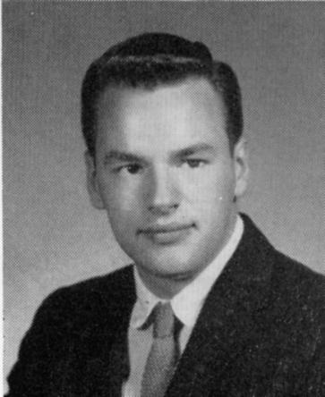
Gary Earl HALL
18742 Wild Horse Farm Court, Wildwood, MO 63038
(636) 273-4641 garyehall@aol.com
After graduation from Gary attended BAC for two years followed by 2 years at Washington University. In 1968, Gary went on the road with his rock show band The Gary Hall Show with TopKat and the Kittens until 1976. (His opening night in Las Vegas coincided with Elvis’ last.)

Spouse Susan from Collinsville is an account manager for Verizon Wireless. Son Christopher is Associates Director of Admissions at Mckendree College. Christopher’s wife, Sherry, is a Graphic Artist for Hall Visual Communications. Granddaughter Aiden Bailey Hall is Papa’s Angel.

Recently built home in West St. Louis County – out with the deer and wild turkeys – but only a 20-minute drive from work; it’s on the edge of a bluff and looks like a tree house.
Gary is an accomplished real estate professional offering 26 years experience in the real estate appraisal and real estate appraisal education business. Significant qualifications include the IFAS Senior Designation with the National Association of Independent Fee Appraisers, Licensed Real Estate Broker in the State of Illinois, and National Instructor of Real Estate Appraisal for NAIFA, where he was the Illinois State Director, National Director and Illinois Appraiser of the Year in 1994. Gary is on the Advisory Board of Southwestern Illinois College and is a real estate instructor for that institution. Prior to joining the Joseph C. Sansone Company, Gary was the Director of Education for the National Assn. of Independent Fee Appraisers. He participated with designated members of the seven Appraisal Foundation sponsors in the development of the National Course on the Uniform Standards of Professional Appraisal Practice for the Appraisal Foundation. Contributing Author for Market Data Analysis Course Textbook and co-author of Introduction to the Personal Computer; Getting the Most From Your Computer Software and Japanese Energy Efficient Housing for Popular Science Magazine, 1985. Mr. Hall has been State Certified in both Illinois and Missouri.

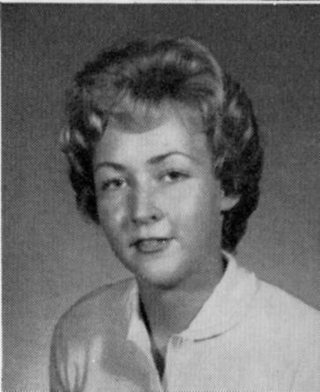
Sandra HAMBLETON Woods
530 West Main, East Galesburg, IL 61430
309-342-7612 jimsandy@galesburg.net
When the boys left home to establish their own families I embarked on a new career: went into the antique business. Had been studying the antique scene for quite a few years so it was a natural progression.

Jim retired at 55 so that we could work together and travel to shows. We like being our own boss and the opportunities we have to explore the country. We set up at shows in the east and in New Mexico. Travel takes us away from home about 3 months of the year.

We are very proud of the way our children have matured and positively glow with pride over our 2 granddaughters (Emma 6, and Alicia 4). Life has not always been a smooth rode--I had a battle with cancer- but God is good, I survived and we are stronger because of the obstacles overcome. Enjoying life a lot. Every day is a gift.

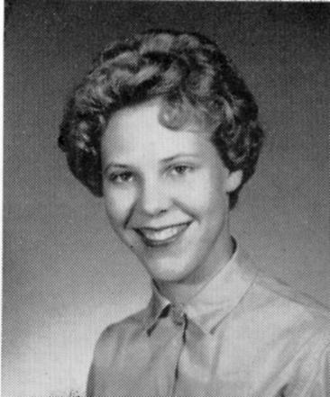
Gay HENTZE Pape
816 Bromfield Terr, Manchester, MO 63021-6718
(636) 391-7190
My life is good! The years have given me a secretarial career (before our children), 32 happy years married to Bob, son David (28), daughter Cindy (25), varied volunteer stints (rewarding), horseback riding and helping at the riding arena (and at World Paint Shows when my pals compete) and (past five years) winter seasons as snowbirds at a fun RV park in Naples, Florida.

Each day is a gift. While fame and fortune have escaped me, laughter, friends and family along with good health keep me happy. I don’t look much different from high school I’m told, but the “hair do” is much better! (My best to all.) My nephew is a teacher at Belleville West.

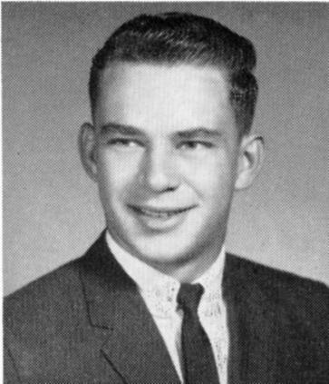 | 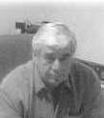
Anthony (Tony) KURKEY
1713 Sprucehill Dr, Belleville, IL 62221
(618) 234-9215 kurkey@peaknet.net
Operates The Kurkey Group, a provider of staffing solutions to the manufacturing market, specializing in the hvac/r and appliance industries.

(1982: "Spouse: Marie Sherman, children: Greg 16, T.J. 8, Tiffany 3. Tony was at the Pentagon, Washington, D.C., for 6½ years while in the service. He now owns his own graphics company, specializing in book and magazine typesetting. The company also specializes in marketing graphics systems within a three state area, which really keeps Tony busy. He has traveled to Canada, and enjoys hunting and billiards in his spare time.")

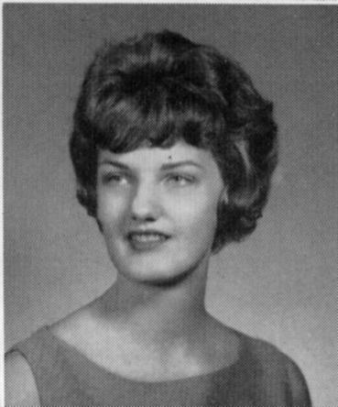 | 
Pat MOEHLE Isom
6826 East Church Avenue, Fresno, CA 93727-6705
isom@lightspeed.net
I always dreamed of living in CA and managed to secure summer work in Yosemite National Park in 64 as a pianist for the Christian Ministry in the National Parks and teletype operator, restaurant hostess and desk clerk for the Yosemite Park and Curry Co. (They move you up).

Here I met my husband Roy who had just graduated from music school at Fresno State. I had been attending U. of I. in Champaign but didn't return in 1965 as my piano teacher, the son of Igor Stravinsky, was headed to Vienna to bring some works of Mozart into print through Peters Urtext Editions. I would rather stay on in CA and go to work for the San Francisco Opera Company, whose assistant stage manager worked in the parks with me and suggested I be a rehearsal pianist for the operas. Roy and I eloped to Las Vegas instead.

Except for a little over a year living in Las Vegas, we have made out home in Fresno where all 3 of our children are living as well. Richard, our oldest is a peace officer, daughter Jen, who also attended U. of I. and completed her PhD in psychology, returned to Fresno when husband Jim accepted a business professorship at California State University. Jen is the mother of Ellie, age almost 3, and Jonah, just a year old Thanksgiving.

Daughter Cathy is news director and anchor for a local news-talk station and "competes" with or receives mentorship from dad, Roy, who is news director for another radio station. I take care of Cathy's son, Nickolas, every day and juggle this responsibility with college music classes that I teach. (I received music degrees and English credentials after the kids started school.)

My most favorite pursuit when I'm not performing on the piano is dancing Argentinean tango--something I stumbled into in conjunction with the world music telecourse I teach. This occupation gets to be an obsession--like all the other obsessions I enjoy: quilting, fabric art, eating!

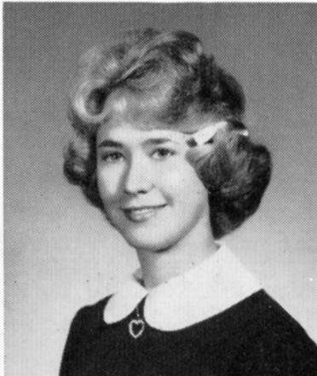 | 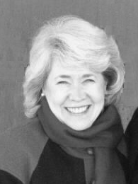
Judy Rae PHILLIPS Rasch
4649 Frank Scott Parkway West, Belleville, IL 62223
raynjudy@compu-type.net
My three sons ages now are Stephen, 34, Thomas, 31, and Joseph, 24. Stephen works as a housing inspector for the City of Belleville and is the father of two daughters, Miranda, 6, and Madelyn, 1 month and 2 weeks old, making me a grandmother. I am also an aunt to my sisters two children, Samuel, 5 and Anna, 4, both adopted from Romania. Thomas, is a high school math teacher at Belleville East High School and Joseph is quite an artist and presently works for an artist doing framing. He still is hoping to continue his education to acquire his Bachelors degree in Art.

I presently work as a part-time receptionist for a Belleville lawfirm and just love it. I'm glad to be out of the full time work field! I still enjoy playing piano - just for my own enjoyment and entertainment. My husband and I have both been married before - Ray was married to Carolee Paul who as you know is now deceased. I was divorced for 5 years when Ray came into my life and being a Catholic, I needed to obtain an anullment from my first marriage - which I was granted - before Ray and I could marry. We were married in June of 1999, so we are still relatively newlyweds and very happy I must say. We both enjoy the simple things in life and are very family oriented. We, of course, especially enjoy our grandchildren.

Hope you have a great time at the reunion - thanks for e-mailing me and hope this gives you a little update on me.
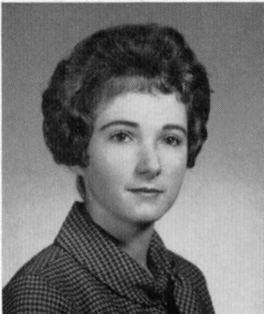
Marsha Lynn PHILLIPS Hentzel
12751 Foxhound Drive, Maryland Hts, MO 63043
(314) 878-7439 stlcats-r-us@worldnet.att.net
Sorry I couldn't be with you all, but circumstances in my life did not permit at this point.

Ron and I have been married 39 years this year and I worked at Monsanto Company in St. Louis from 1979 to 2002, as an Executive Secretary. I left due to disability from replacements of both knees and the curse of our time, osteoarthritis. I am managing fairly well; not my dream, but life does throw us all unexpected bends in the road.

Our "children" are now 36 and 32. The years go by quickly, don't they?

We are now the proud grandparents of Sydney, who is 3 months old. My son and his wonderful wife gave us this gift on September 26; she is our miracle baby due to Michele's many problems with endometriosis. They live in Irvine, CA, and we visit at least twice a year (may be more now)!

Our daughter is 32 and is working toward becoming a police officer. It took her a while to find her "place", but she is working on domestic abuse cases and educating both police officers and the public about it.

I still very much enjoy Bible study, reading, feeding birds, and caring for a colony of feral cats. God bless you all and maybe I'll see you next time. Marsha

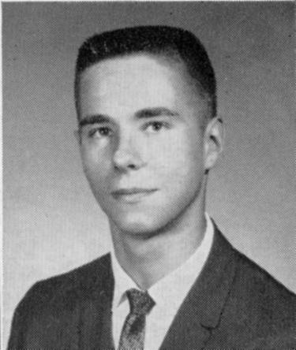 | 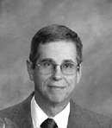
Luke ROSE
64 Grand Rio Cir, Sacramento, CA 95826
(916) 383-4831 LeRose@prodigy.net
Earned Ph.D. in Biomedical Engineering. Career spent with small medical device companies. Involved in design and development of intravascular ultrasound and robotics devices for joint replacement surgery.

Married 31 years to wife Angela. One daughter, (Annette), currently attending college at UC Irvine.

Enjoy outdoor activities, including hunting, fishing, camping, and wildlife conservation projects.

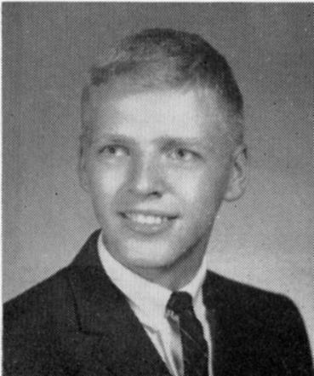 | 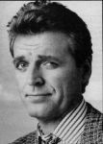
David RASCHE
*2336 22nd St, Santa Monica, CA 90405
(310) 454-7342 dwrasche@yahoo.com
After BTHS I grudgingly got a degree from Elmhurst College, but had no direction. Ended upgetting an MA in English from U of Chicago, then spent two years in Divinity School there, but it was all a dead end and it was the beginning of a fight with depression which I am winning, but is still a struggle.

By chance, I happened upon Second City in Chicago, and I knew in an instant that’s where I belonged. 2 years there, then to NYC and acting classes, plays, TV and some movies…and I met my wife, Heather, who is very wise and funny and that’s why I dislike her so intensely.

We ended up having three children, now 20, 17 and 14. Moved back and forth between NY and LA, and now we live in Santa Monica. It has been fun, but very difficult…when I am working, it is exhiliration and thrills, but there are long, often very long periods of extreme uncertainty. I’ve done 4 shows on Broadway, many off and off-off, episodic TV, including ‘Sledge Hammer’ in 1986, and some movies one was ‘The Divine Secrets of the YaYa Sisterhood,’ and one opens in January, “Just Married.

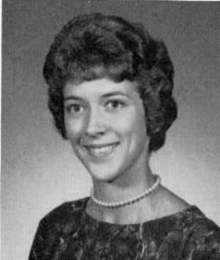
Nelda E GOLDSMITH Reames
613 E 7th St, Maryville, MO 64468-3226
(660) 582-7742 nelereames@hotmail.com
I married classmate Bob Reames, and we are now divorced but we remain on good terms. My two children, Robin and Brian live in the same town that I do. I have two wonderful grandsons 10, 101/2 yrs old.

I work for a printing company based out of New Hampshire. Maryville, MO is the home of the Northwest Missouri State University

I am a cancer survivor, and I am active in many Cancer Walks in my community and surrounding towns. I live 30 miles North of St. Joseph, MO which is 50 Miles North of Kansas City.

I love college, NFL and our high school football games. We spend our summers boating on Mozingo Lake just 8 miles out of town.

I visit home often to see my mother, Mildred Goldsmith. She is 84 and going strong.

Sorry I cannot be there, but will try for next reunion.

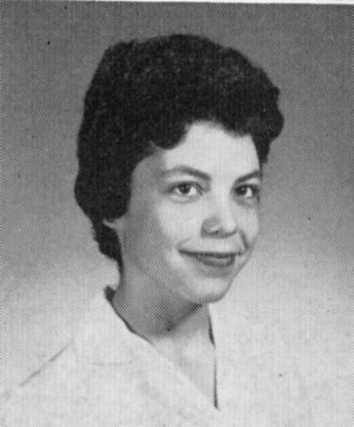
Carla VASQUEZ Schuller
P.O. Box 141698, Austin, Texas, 78714-1698
(512) 339-7006 schucar@hotmail.com
11203 Brushy Glen Dr, Austin, TX 78754-2007, (512) 339-7006.

Director, Alamogordo New Mexico Public Library. (505) 439-4140. Commutes back and forth between Alamogordo and Austin TX.

B.A. in English, M.L.S., 3 LIFE California Teaching Credentials.

Married Jack Schuller at the Kensington Registry, London, England. No children.

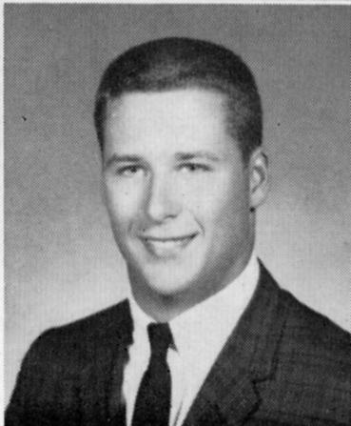
Jay Eugene WIDMAN
5810 Woodland Creek, Kingwood, TX 77345
(281) 360-7192 jwidman@Houwire.com
I just got back from Europe. I spend a good deal of time in both western and eastern, plus Canada. I am in the U.S. the remainder of Dec., but will start traveling again in Jan. I would love to attend but need to spend some time at home before I start traveling again in January.

To give you a snapshot of what I do, I am V.P. of Engineering for HWC (Houston Wire and Cable). Four of us plus a holding company out of Chicago own the company. We ship electrical cables, fiber optic up to 35KV all over the world and have 9 locations in the U.S.. We also design cables and connectorization products for the cables. So, it keeps me fairly busy. I hope to be able to retire in the not to distant future, but we shall see.

As for history, I served for 4 years in Special Operations as a member of a HALO Team (High Altitude Low Opening) dealing in covert operations. After that stint, I returned to college and taught flying for Louisiana Tech Univ. in Ruston LA. Later I got involved in the electrical end of business for the pulp and paper industry and things evolved from there. We started HWC in 1978 and I have been here since.

I have a daughter, Kelsey, who is in pediatrics at Texas Childrens Hospital. Thats about all. I still do a lot of hiking in various parts of the world when I have the opportunity and enjoy outdoor photography, skiing and do some wood working.

Both my parents are deceased, so I don't visit Belleville much anymore. One of my sisters is in Mobile, the other in Colorado Springs.

My best to all those who I have not seen for eons.

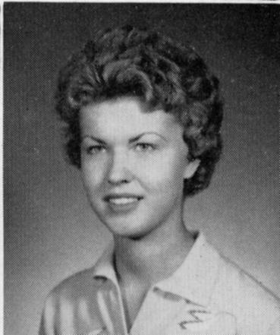
Beverly WINKER Scranton
1817 27th Ave Place, Moline, IL 61265-5219
(309) 764-4114 golfgal44@netzero.net
Bev still has the same children and same husband after all these years. Jim and I will be married 38 years on Friday, Dec. 27th. Rob is now 34 years old and is a Doctor of Chiropractic. He has a B.S. from U. of Illinois and also is a graduate of Palmer College of Chiropractic. He & his wife, Robyn are presently in Australia celebrating Christmas with her family & meeting all of his in-laws. Rob's practice is in Rock Island, IL. We feel lucky that they live only 6 blocks from us. Paul is 31 and graduated from Drake University. He is a financial planner with Smith Barney in Bettendorf, IA (which is just across the Mississippi River from Moline). Paul is married to Emily and they have 1 daughter, "Ellie", 11-months old. J is 28 years old and a Drake University graduate. He works for Best Buy at their corporate office in Minneapolis, MN.

Some happy events from their years at home - All three boys played varsity tennis and basketball. Paul & J were both All State Tennis players. Paul was captain of Moline High basketball team (Moliners are also "Maroons" and they too are asking the question - What is a Maroon, anyway?). With all the sports the boys played, the furtherest I've traveled was to England where I watched Rob play football for the University of Warwick Wolves. Most down period I have experienced was dealing with our son's bout with cancer when he was at college. How I wonder at his ability to perform for his finals while going through some serious chemotherapy. Scariest experience was when I worked as a teacher's aide in a school for delinquent boys and one 6'4" 16 year old attempted to kidnap me when I was returning him to the school for off grounds GED testing. He put his hands around my neck and told me to drive the van out of town. I caught him off guard when I wheeled the van into a power company crew doing some repair work and slammed on the brakes.

I now work for the same school district but am an elementary school secretary and am happy to be there. Jim is a retired pharmacist and now manages our properties and apartments. We moved into a new home last Thanksgiving. We designed the home ourselves and are still speaking to one another. Home building is something everyone should do - once!

I still love to play golf. I have just about given up volleyball - jammed fingers take longer to heal! I believe in moderate exercise and plan on keeping that up as long as I can still stand. When I'm in my 70's I want to be able to still climb Camelback Mountain, AZ and do it with my grandchild(ren). We still enjoy camping - especially along the Mississippi River.

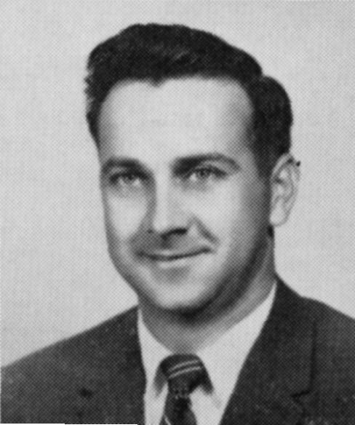
Dan Wolford
6701 Concordia Rd, Belleville, IL 62223
Mr. Wolford, one of our BTHS teachers. Thank you for the invitation to the Class of 62 reunion. I have many fond memories of this class. I have watched while the members of the class have become teachers, lawyers, business people, leaders in the community, and hard working men and women that make the world go 'round.

As I write this letter, it is Veteran's Day and I always think of Terry Pensoneau, who lost his life in Vietnam, as well as the many classmates that served in the armed forces. The country was starting the Peace Corps, and Melvin Zielinksi, at the time the youngest person to become a Peace Corps member, was sent to Bolivia. One of your classmates that became a teacher at Belleville West replaced me when I retired, and now, he too is retired. Time flies.

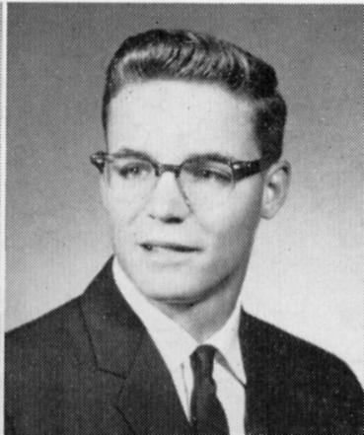
Sylvan ZAHN
509 Garden Blvd, Belleville, IL 62220
(618) 277-6757 SylZ@hntlgh.com
Upon graduation from the Virginia Military Institute in ‘66 Syl received a BA in History. While at VMI, he received the Commendation as a distinguished military and academic graduate and was listed in Who’s Who. Syl then entered the Airborne Infantry and served from ‘66 - ’68 being stationed at Fort Benning; Ft. Campbell; Ft. Bragg, and of course Viet Nam. From ‘68 - '70 Captain Zahn was Stationed with the AGC in Jefferson City, Mo. While Syl was serving in the Army he received the Silver Star, Bronze Stars, the Air Medal and Ar Com. In 1971 he received his MBA in Finance from the U. of Mo, where he was named the top graduate of the Business School.

From 1971 to 1988 Syl worked for Goldman, Sachs, & Co., the last ten years of the period managing the midwest regional office for the firm. In 1988 Syl became part of a three person investment partnership which has been involved a variety of business ranging from vehicle leasing, securities brokerage, sport yacht manufacturing, and pro football (a bizarre tale). In 1968 Syl married Mary McKelvey (BTHS 64 - Randolph Macon 68). Syl and Mary still reside in Belleville – although over the last dozen years have been spending at least several months of the winter on Sanibel Island, Florida.

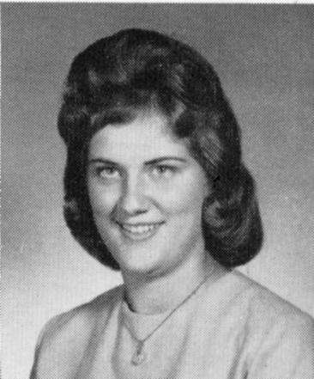
Jannetje (Jane) [KROESEN] Windsor
21 Orlando Place, Fairview Hts, IL 62208
(618) 632-7359 EdJane_Windsor@aol.com
I married Edward Windsor (BTHS '61) June 4, 1966. Ed has been employed by Boeing for almost 40 years. We have lived our entire life in this area. After raising our three children, I went to work for a Day Care where I teach preschoolers - a job I love.

We have three children: Tracy Jane 34, Scott Edward 31, and Nancy Lynn 27. Our daughter Tracy works as a massage therapist, son Scott works as an electrician, and Nancy works in a downtown law firm. We also have a wonderful grandson, Hayden Scott 18 months, who is our pride and joy. Another grandchild is due in June.

We have enjoyed traveling including a cruise and planning to do some more traveling. I was diagnosed with breast cancer in June 2001. I am cancer-free as of today. I try to live life to the fullest, and thank God for each day. I volunteer for Southern Illinois Hospice and take part in several cancer walks. Now we are looking forward to retirement and spend more time with the children and grandchildren. See you all August 11, 2007.

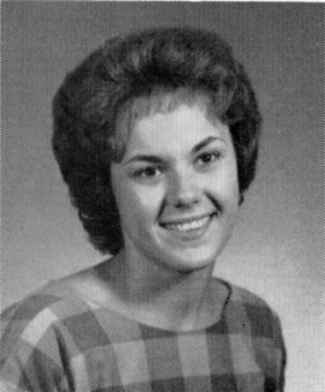
Bonnie Kay [MUELLER] Hundelt
19606 Bruces Place, Canyon Country, CA 91351
(661) 299-5158

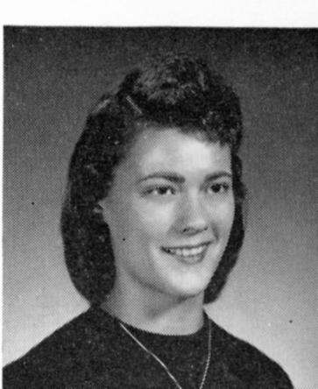
Carol [SCHAPERKOETTER] Johnson
5 Schaperkoetter Dr, Fairview Hts, IL 62208-2231 (618) 632-4743
40 Years – Wow! How time does fly.

I have remained in the area the whole time. After graduation, I workd as a ceeptionist for General Adjustment Bureau in St Louis., Then I workd as a Clerk-Librarian for Pontiac -- William Holiday School District # 105 for 11 years (1979 – 1990). Then I had the pleasure of working with our fellow classmate Lynn Fischer Rogers who was a 5th grade teacher at the school. I have working the past 12 years for Barnes – Jewish Hospital in St Louis. I am presently a Desk Representative for Guest and Patient Relations at the Hospital.

I was married for 27 years, and I have been divorced for the last 14 years. I have been dating a very nice gentleman named Jay Peterson for 10 years. I have been blessed with 3 children and 3 grandchildren. I have two daughters and one son: Connie Rae Sontheimer 38, Margery June Rochell 32, Avey William Johnson 31. I have two graddaughters and one grandson: Audie Wm. Rochell 12, Danielle Elise Rochell 7, and Abby Lynn 5 months.

I want to thank all of you who worked on the 40th Class Reunion. I helped on the 20th, and I know you all put a lot of time and work into planning it. Thanks, again.

Dick Hunsaker (teacher)
215 Country Club Lane, Belleville, IL 62223 (618) 398-5807 hunsaker@ez1.com

Robert Gentsch (teacher)
26 Palmetto Dr., Belleville IL 6221-4362
I'm sorry I cannot attend. We are having out-of-town visitors during the holiday. I thank you very much for thinking of me. Don’t we all remember the packed halls at BTHS during those early ‘60’s? I went to East when it opened in 1966 and retired from there in 1989.

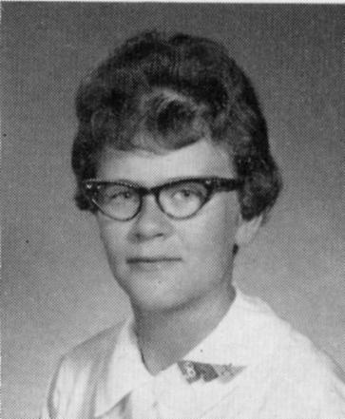
Brenda Lee KRIEGESKOTTE
HC 1 Box 477, Old Town, FL 32680
(352) 542-8180 truman1@bellsouth.net
Retired

Ethelyn Boyd (teacher)
52 W. Main St., Mascoutah, IL 62258
(618) 566-2254
I was delighted and honored to receive your kind and most gracious invitation, and it is with great pleasure that I accept. You indicated that a classmate would provide transportation. How very thoughtful. Without this I would not be able to accept. At age 95, I do not drive on a highway, especially at night.

Fredrick Kunze (teacher)
3245 Arrow Lane, Belleville, IL 62221
(618) 539-5355
I left Township when you did, spent a year in Morocco, one in England, and three in Turkey and then returned to West H. S. where I taught Spanish until I retired in 1988. In 1970, I bought a small wooded world near Freeburg where I have been very very happy. A year ago, I published a book, Thoughts and Favorite Quotations, which many of you heard when you were in my English class. This past week I went through the ’62 Bellevinois, recalling names and faces with many heartwarming memories. You were a great class, and I thank you for inviting teachers to be your guests. Your class always had CLASS!

Elmer Gyerman Teacher)
316 McKinley Dr, Belleville, IL 62220-3738
Thank you very much for your class of "62" reunion invitation. Unfortunately because of another commitment which cannot be changed, we must forgo attending. In the past, I have enjoyed attending class reunions. It is always great to visit with my former students. I wish the class of "62" a very happy reunion and wish to congratulate you on your 40th anniversary.

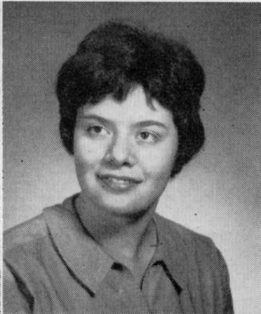
Sandra [RICHTER] Sparks
2942 Guilford Avenue, Baltimore, MD 21218
(410) 243-2156 ssparks@mdo.net
2002 proved to be a great year of transition, completing 13 years as an Executive Director of two community umbrella organizations and separating from my husband of 36 years.

In April, I was honored a second time as one of Maryland’s Top 100 Women, based largely on my extensive volunteer involvement in Baltimore. I am most proud of the Village Learning Place, an original Enoch Pratt Free Library branch (1896) in the Charles Village neighborhood that reopened in June 2000 as a beautifully restored library and learning center with a cafe run by teen entrepreneurs. Seeing is believing—check out www.villagelearningplace.org for this amazing non-profit model. I also chair the Baltimore Alliance for Great Urban Parks, which is working to create sustainable funding for our great but neglected park system. I was delighted that metropolitan St. Louis, including St. Clair County, established a dedicated fund for parks and water quality in 2000—a campaign model for Baltimore.

Over the last three years, I plunged into renovating my three-story Charles Village row house, where I have lived since 1970. Actually, I started with rebuilding the garage for my VW silver beetle and re-landscaping the backyard. Whenever possible, I love traveling and most recently enjoyed 12 days touring Southwest France. Thanks to all the BTHS Reunion Committee for planning this long-awaited event to coincide with a holiday trip to Belleville.

